BUDGET LINE

The budget line can be defined as a set of combinations of two commodities that can be purchased if whole of income is ,spent on them and its slope is equal to the negative of the price ratio. The budget line shows all those combinations of two goods which the consumer can buy spending his given money income on the two goods at their given prices.

Suppose our consumer has got income of Rs. 50 to spend on goods X and Y. Let the price of the good X in the market be Rs. 10 per unit and that of Y Rs. 5 per unit. If the consumer spends his whole income of Rs. 50 on good X, he would buy 5 units of X; if he spends his whole income of Rs. 50 on good Y he would buy 10 units of Y. If a straight line joining 5X and l0Y is drawn, we will get what is called the price line or the budget line. A look at Fig. 1 shows that with Rs. 50 and the prices of X and Y being Rs. 10 and Rs. 5 respectively the consumer can buy l0Y and OX; or 8 Y and 1X; or 6Y and 2X, or 4 Y and 3X etc.

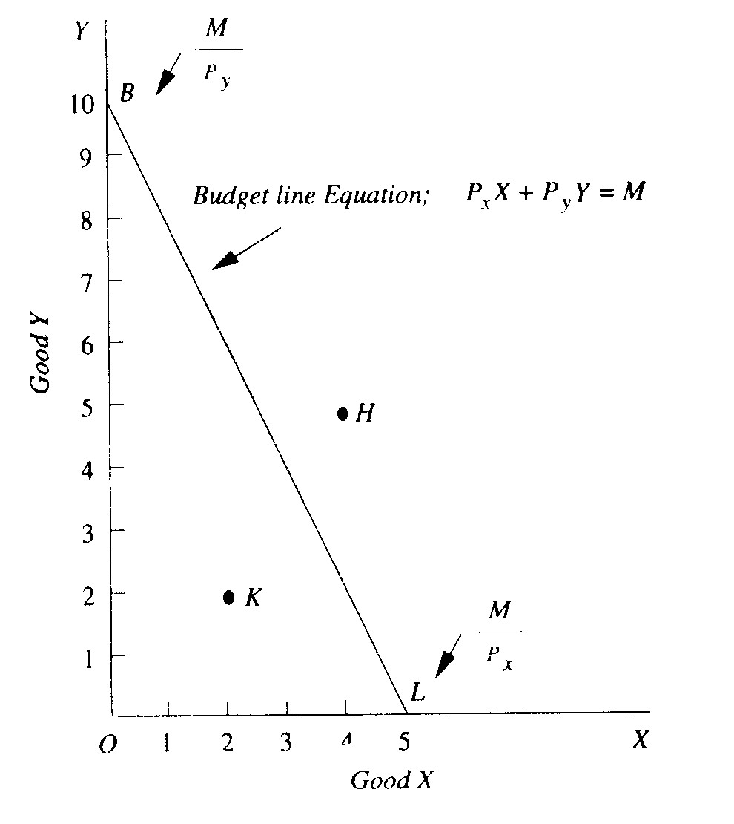

FIG:1 The Budget Line

In other words, he can buy any combination that lies on the budget line with his given money income and given prices of the goods. It should be carefully noted that any combination of goods as H (5Y and 4X) which lies above and outside the given budget line will be beyond the reach of the-consumer. But any combination lying within the budget line such as K (2X and 21) will be well within the reach of the consumer, but if he buys any such combination he will not be spending all his income of Rs. 50. Thus, with the assumption that whole of the given income is spent on the given goods and at given prices of them, the consumer has to choose from all those combinations which lie on the budget line.

It is clear from above that budget line graphically shows the budget constraint. The combinations of commodities lying to the right of the budget line are unattainable because income of the consumer is not sufficient to be able to buy those combinations. Given his income and the prices of goods, the combinations of goods lying to the left of the budget line are attainable, that is, the consumer can buy any one of them.

The budget line can be written algebraically as follows :
P_{x}.X + P_{y}.Y = M
Where P_{x} and P_{y} denote prices of goods X and Y respectively and
M stands for money income

Solving the equation for Y we have the following alternative form of the budget equation.
Y= 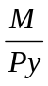 ─ 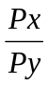 . X
The first term on the right side of the budget equation , that is, M/P_{y}, shows the amount of commodity Y that can bought if quantity purchased of X is zero. In Figure:1, this is represented by the distance OB on the Y-axis. Thus M/Px is the vertical intercept of the budget line equation. The second term on the right hand side of the equation has the coefficient which equals the slope of the budget line.

Budget Space

A budget space shows a set of all commodity combinations that can be purchased by spending the whole or a part of the given income. In other words, budget space represents all those combinations of the commodities which the consumer can afford to buy, given the budget constraint. Thus, the budget space implies the set of all combinations of two goods for which income spent on good X (i.e P_{x}.X) and income spent on good Y(i.e P_{y}.Y) must not exceed the given money income. Therefore, we can algebraically express the budget space in the following form of inequality.

P_{x}X + P_{y}.Y≤ M, or M ≥ P_{x.} X + P_{Y.}Y

The budget space has been graphically shown in Figure 6.22 as the shaded area. The budget space is the entire area enclosed by the budget line BL and the two axes.

Fig. 2. Budget space

Changes in Price and Shift in Budget Line

Now, what happens to the price line if either the prices of goods change or the income changes. Let is first take the case of the changes in prices of the goods. This is illustrated in Fig. 3. Suppose the budget line in the beginning is BL, given certain prices of the goods X and Y and a certain income.

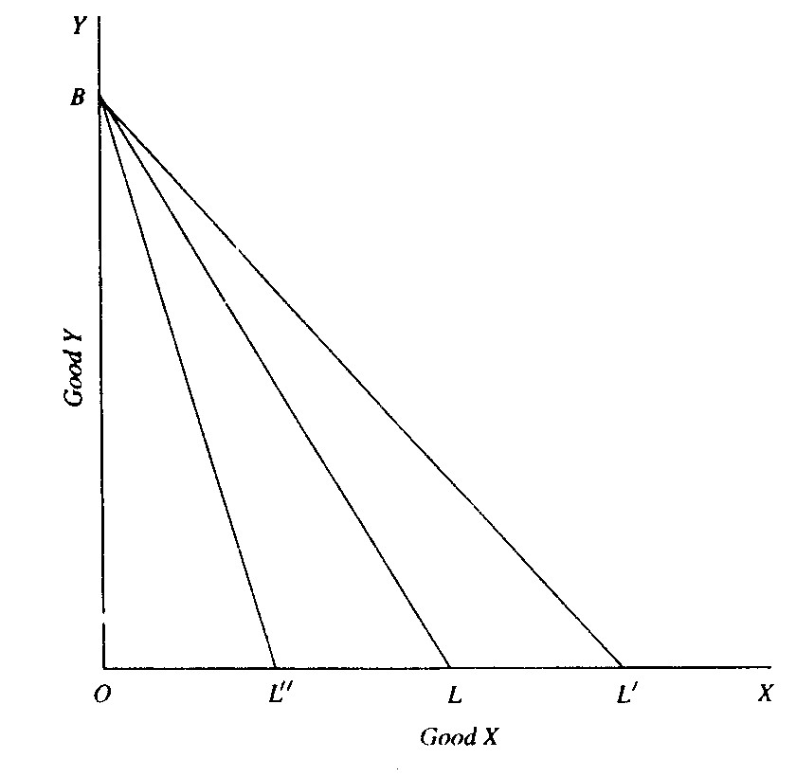

Fig.3 Changes in budget line as a result of
Changes in price of good X

Suppose the price of X falls, the price of Y and income remaining unchanged. Now, with a lower price of X the consumer will be able to purchase more quantity of X than before with his given income. Let at the lower price of X, the given income purchases OL' of X which is greater than OL. Since the price of Y remains the same, there can be no change in the quantity purchased of good Y with the same given income and as a result there will be no shift in the point B. Thus, with the fall in the price of good X, the consumer's money income and the price of Y remaining constant, the price line will take the new position BL'.
Now, what will happen to the budget line (initial budget line BL) if the price of good X rises, the price of good Y and income remaining unaltered. With higher price of good X, the consumer can purchase smaller quantity of X, say OL", than before. Thus, with the rise in price of X the price line will assume the new position BL".

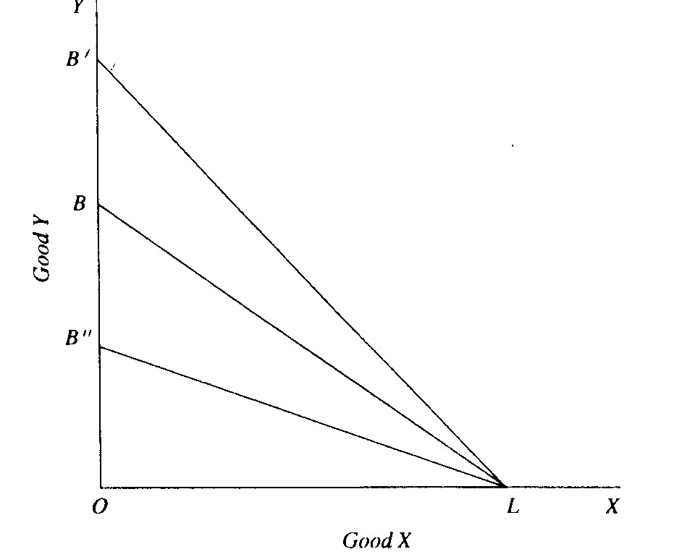
Fig.4 Changes in budget line as a result of
Changes in price of good Y

Fig. 4 shows the changes in the price line when the price of good Y falls or rises, with the price of X and income remaining the same. In this the initial budget line is BL. With the fall in price of good Y, other things remaining unchanged, the consumer could buy more of Y with the given money income and therefore budget line will shift to LB'. Similarly, with the rise in price Y, other things being constant, the budget line will shift to LB".

Changes in Income and Shifts in Budget Line

Now, the question is what happens to the budget line if the income changes, while the prices of goods remain the same. The effect of changes in income on the budget line is shown in Fig. 5. Let BL be the initial budget line, given certain prices of goods and income. If the consumer's income increases while the prices of both goods X and Y remain unaltered, the price line shifts upward (say, to B'L') and is parallel to the original budget line BL. This is because with the increased income the consumer is able to purchase proportionately larger quantity of good X than before if whole of the income is spent on X, and proportionately greater quantity of good Y than before if whole of the income is spent on Y. On the other hand, if the income of the consumer decreases, the prices of both goods X and Y remaining unchanged, the budget line shifts downward (say, to B"L") but remains parallel to the original price line BL. This is because a lower income will purchase a proportionately smaller quantity of good X if whole of the income is spent on X and proportionately smaller quantity of good Y if whole of the income is spent on Y.

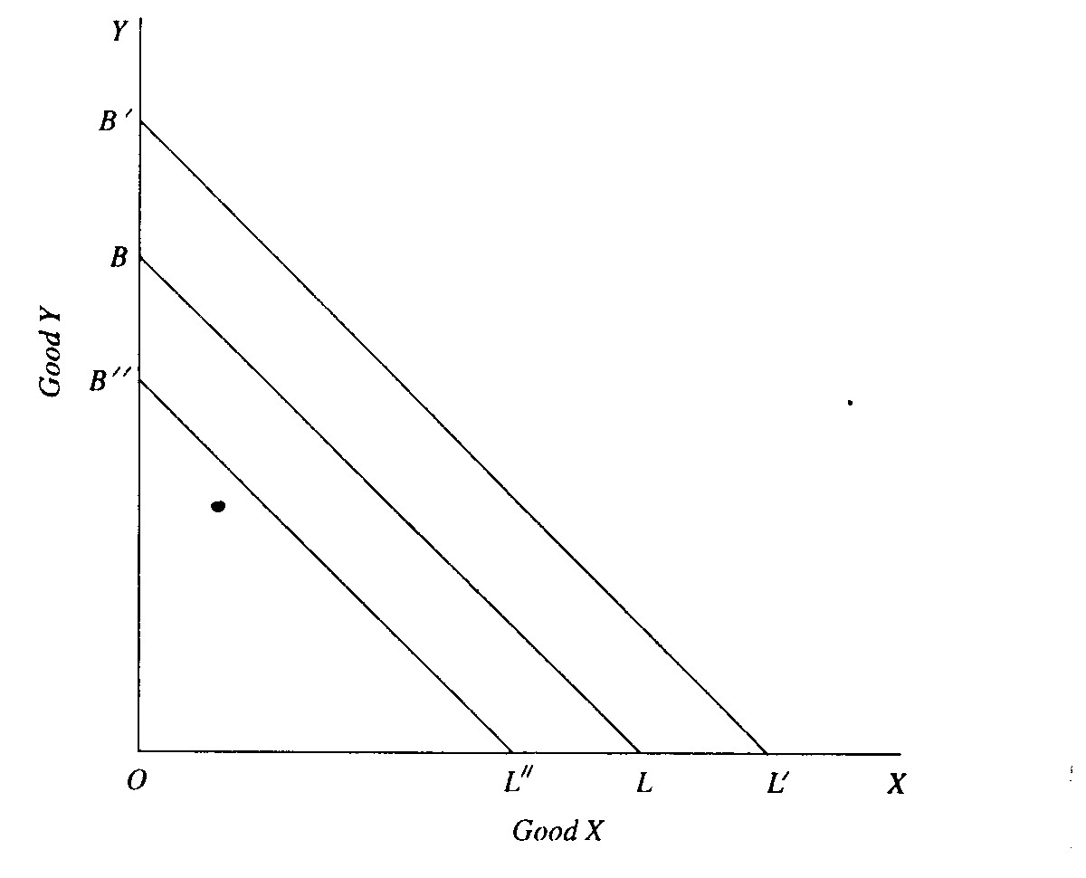

Fig. 5. Shifts in Budget Line as a result of Changes in income

CONSUMER'S EQUILIBRIUM: MAXIMISING SATISFACTION

A consumer is said to be in equilibrium when he is buying such a combination of goods as leaves him with no tendency to rearrange his purchases of goods. He is then in a position of balance in regard to the allocation of his money expenditure among various goods. In the indifference curve analysis it is assumed that the consumer tries to maximize his satisfaction.

We shall make the following assumptions to explain the equilibrium of the consumer:

(1) The consumer has a given indifference map exhibiting his scale of preferences for various combinations of two goods, X and Y

(2) He has a fixed amount of money to spend on the two goods. He has to spend whole of his given money on the two goods.

(3) Prices of the goods are given and constant for him. He cannot influence the prices of the goods by buying more or less of them.

(4) Goods are homogeneous and divisible.

(5) the consumer is assumed to be rational in the sense that he aims at maximizing his satisfaction.

It will be seen from Fig. below that the various combinations of the two goods lying on the budget line BL and which therefore he can afford to buy do not lie on the same indifference curve; they lie on different indifference curves. The consumer will choose that combination an the budget line BL which lies on the highest possible indifference curve. The highest indifference curve to which the consumer can reach is the indifference, curve to which the budget line BL is tangent. Any other possible combination of the two goods either would lie on a lower indifference curve and thus yield less satisfaction or would be unattainable.

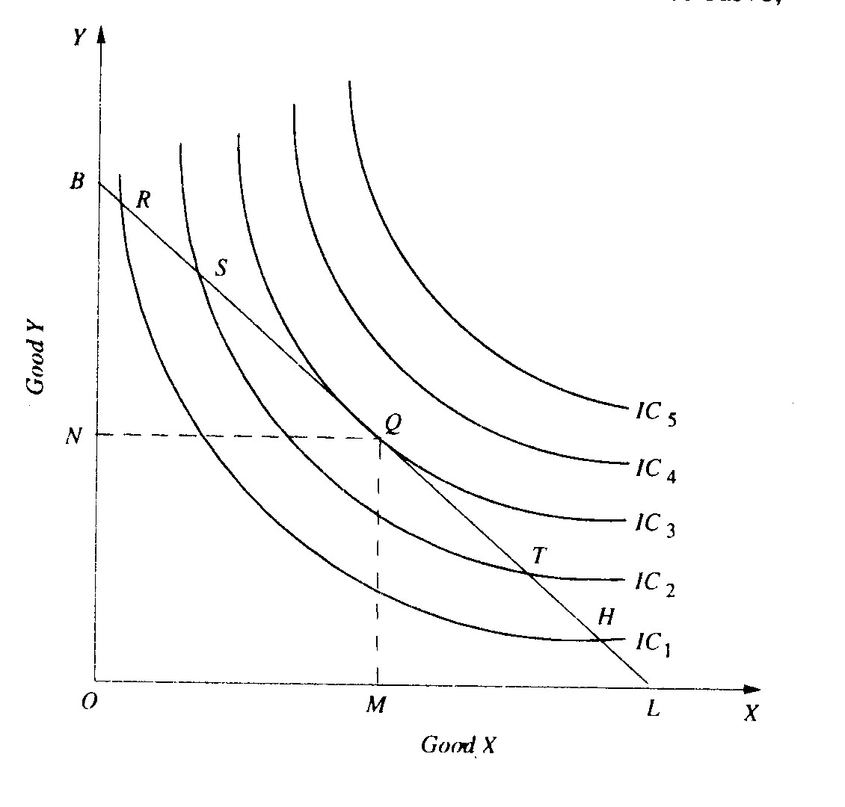

Fig: 5 Consumer’s Equilibrium

In Fig. 5 budget line BL is tangent to indifference curve IC₃ at point Q. Since indifference curves are convex to the origin, all other points on the budget line BL, above or below the point Q, would lie on the lower indifference curves. Take point R which also lies on the budget line BL and which the consumer can afford to buy. Combination of goods represented by R costs him the same as the combination Q. But, as is evident, R lies on the lower indifference curve IC₁, and will therefore yield less satisfaction than Q.
Likewise, point S also lies on the budget line BL but will be rejected in favor of y since S lies on the indifference curve IC₂, which is also lower than IC₃, on which Q lies. Similarly, Q will be preferred to all other points on the budget line BL which lies to the right of Q on the budget line, such as T and H. It is thus clear that of all possible combinations lying on BL, combination Q lies on the highest possible indifference curve and yields maximum possible satisfaction.
Of course, combinations lying on indifference curves IC₄, and IC₅ will give greater satisfaction to the consumer than Q, but they are unattainable with the given money income and the given prices of the goods as represented by the budget line BL.
It is therefore concluded that with the given money expenditure and the given prices of the goods as shown by BL the consumer will obtain maximum possible satisfaction and will therefore be in equilibrium position at point Q at which the budget line BL is tangent to the indifference curve IC₃. In this equilibrium position at Q the consumer will buy OM amount of good X and ON amount of good Y.

Second Order Condition for Consumer Equilibrium

The tangency between the given budget and an indifference curve is a necessary but not a sufficient condition for consumer's equilibrium. The second order condition must also be fulfilled. The second order condition is that at the point of equilibrium indifference curve must be convex to the origin., or to put it in another way, the marginal rate of substitution of X for Y must be falling at the point of equilibrium.

It will be noticed from Fig. 5 above that the indifference curve IC₃, is convex to the origin at Q. Thus at point Q both conditions of equilibrium are satisfied. Point Q in Fig.5 is the optimum or best choice for the consumer and he will therefore be in stable equilibrium at Q.

But it may happen that while budget line is tangent to an indifference curve at a point but the indifference curve may be concave at that point. Take for instance, Fig. 6 where indifference curve IC₁, is concave to the origin around the point J. Budget line BL is tangent to the indifference curve IC₁, at point J But J cannot be a position of equilibrium because satisfaction would not be maximum there. Thus the consumer by moving along the given budget line BL can go to points such as U and obtain greater satisfaction than at J.
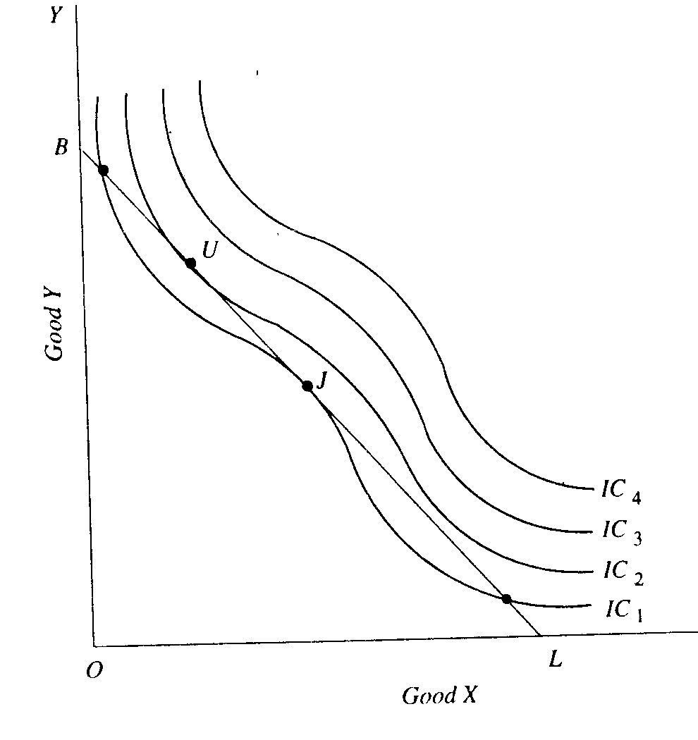

Fig:6 Second Order condition for Consumer’s Equilibrium

We therefore conclude that for the consumer to be in equilibrium, two conditions are required :

1. A given budget line must be tangent to an indifference curve, or marginal rate of substitution of X for Y (MRS_{xy}.,) must be equal to the price ratio of the two goods .
2. Indifference curve must be convex to the origin at the point of tangency.

